Kevin Charles Hostler

After speaking with Leonardo today the plan for next week and the beginning model is as follows.

1. I need to get familiar with how to create cube files in the following format
   1. 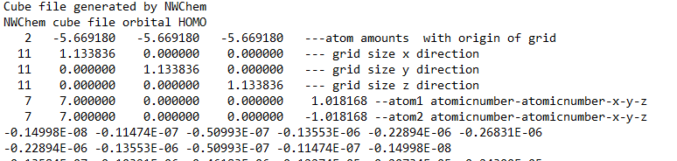
2. I need to create multiple training set with the following parameters
   1. Start with one element, hydrogen to start
      1. 1 atom
         1. 10 x 10 x 10 grid
            1. Go through each point of placement and train to spot the differences
         2. Increase grid repeatedly
      2. If the above yields positive results, then we will move on to increasing the amount of hydrogen atoms with increasing grid sizes

Through out all of this I want to automate creating and saving models with varying degrees of predictive abilities.

Along with this are the following facts going into this

* Grids are set per dataset
* Atom amounts are set per dataset
* The most common elements are H, He, Si, C, N , O